Time Series Analysis of Gold ETF Prices
DATS 6313 – Time Series Analysis
Final Term Project

Submitted by:
Name: Mohammed Hussain Nathani
GWID: G36308827
Course: DATS_6313_10
Instructor: Dr. Reza Jafari
Semester: Spring 2025
Submission Date: May 4, 2025

2. Table of Contents
- Cover Page
- Table of Contents
- List of Figures and Tables
- Abstract
- Introduction
- Description of the Dataset
- Stationarity Analysis
- Time Series Decomposition
- Holt-Winters Method
- Feature Selection and Dimensionality Reduction
- Base Models
  - Average, Naïve, Drift, Simple, Exponential Smoothing
- Multiple Linear Regression Model
- ARMA-ARIMA-SARIMA/Multiplicative model
- ARMA-ARIMA-SARIMA/Multiplicative model
- Box-Jenkins Model
- Residual Diagnostics and Model Validation
- Forecasting Function
- Final Model Selection and Comparison
- Final Model h-Step Ahead Prediction
- Summary and Conclusion
- Appendix: Python Code (Toolbox.py)
- References

3. List of Figures and Tables

Number of Figures: 49
Number of Tables: 4

4. Abstract

This project presents a comprehensive time series analysis of Gold ETF Close Prices, aiming to uncover temporal patterns and develop predictive models for future price forecasting. Utilizing a multivariate dataset sourced from Kaggle, which includes key financial indicators such as S&P 500, NASDAQ, CPI, GDP, and various commodity prices, the study focuses on modelling the gold price over time.
Initial exploratory analysis reveals that the gold price series exhibits significant non-stationarity, influenced by strong trend and moderate seasonality. Statistical tests such as the Augmented Dickey-Fuller (ADF) and KPSS confirm the need for transformation. A thorough decomposition using the STL method helps isolate the trend and seasonal components, further supporting model selection.
Various forecasting models are explored, including Base Models, Holt-Winters Exponential Smoothing, ARMA, ARIMA, and Box-Jenkins methodologies. Regression analysis is also conducted using macroeconomic variables, incorporating feature selection techniques like PCA and VIF to address multicollinearity. Baseline models (naïve, drift, average) are used for comparison against more complex methods.
The final selected model is determined based on diagnostic tests, error metrics (MSE, RMSE, AIC, BIC), and forecasting accuracy on the test set. The analysis concludes with h-step ahead forecasting, and (if implemented) a web-based dashboard is proposed to visualize model predictions interactively.
This study highlights the effectiveness of time series modelling in financial forecasting and provides valuable insights into the behaviour and predictability of gold prices, supporting data-driven investment decision-making.

5. Introduction

Time series analysis is a crucial statistical technique used to model and predict sequential data that evolves over time. In financial markets, time series methods are extensively employed to analyse asset prices, identify patterns, and make data-driven forecasts. These techniques leverage temporal dependencies, trends, seasonality, and cyclical behaviour to understand underlying dynamics in time-stamped data.
This project focuses on the time series analysis and forecasting of Gold ETF Close Prices using historical financial data. Gold is widely recognized as a hedge against inflation and market volatility, making it a critical asset in diversified portfolios. By analysing its price behaviour over time, we aim to build predictive models that can provide valuable insights for investors and analysts.
The analysis begins with preprocessing and exploring the dataset, which contains several economic and market variables including equity indices (S&P 500, NASDAQ), commodity prices (oil, silver, platinum), and macroeconomic indicators (CPI, GDP). The selected dependent variable is the Gold ETF Close Price, and the goal is to model its behaviour using both traditional time series models and machine learning-inspired regression approaches.

The project follows a structured approach:
Step 6: Dataset description, preprocessing, and exploratory analysis using plots, correlation matrices, and autocorrelation tools.
Step 7: Stationarity checks using ADF and KPSS tests, along with rolling statistics and necessary transformations like differencing.
Step 8: Decomposition of the series into trend, seasonal, and residual components using STL (Seasonal-Trend decomposition).
Step 9: Forecasting with the Holt-Winters method.
Steps 10–12: Feature selection using PCA/VIF and regression modelling to assess linear relationships.
Step 13–15: Development of ARMA, ARIMA, SARIMA, and Box-Jenkins models with order selection using the GPAC method, and LM algorithm.
Step 16: Residual diagnostics and validation tests to ensure model robustness.
Steps 17–19: Forecasting future gold prices using selected models, evaluating h-step predictions, and comparing performance across all modelling techniques.
The final objective is to select the most accurate model for forecasting Gold ETF Close Prices, supported by statistical evaluation and visualization. Additionally, a dashboard may be developed to present model outputs in an interactive format (bonus).
This comprehensive process demonstrates the power of time series analysis in uncovering insights from financial data and building models capable of future prediction with statistical confidence.

6- Description of the dataset

6 a.
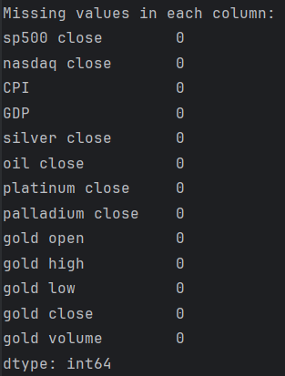
Fig. 1

6 d.
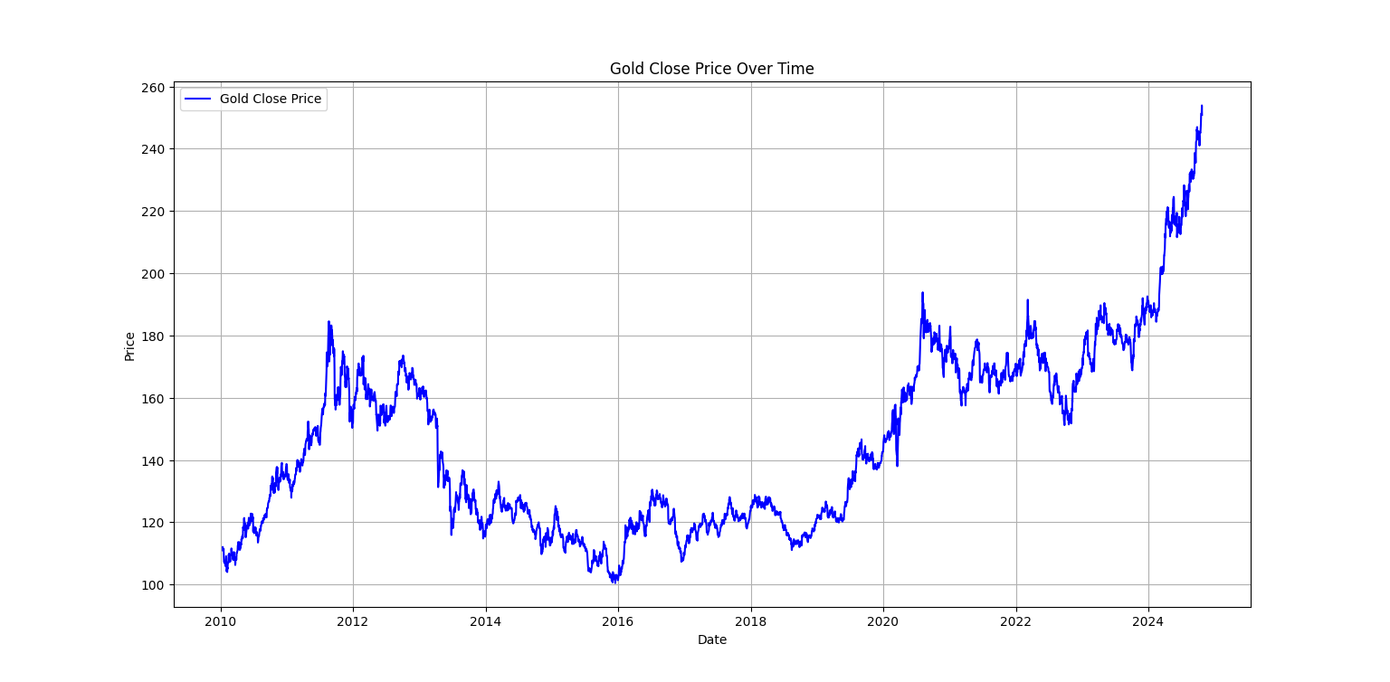
Fig. 2

Plot of the Dependent Variable (Gold Close Price vs Time)

Observations:
- The Gold Close Price shows a clear upward trend over time, especially from around 2020 onwards.
- The time series is non-stationary, evidenced by a steadily increasing mean and fluctuations in variance over time.
- There are cyclical fluctuations that suggest potential seasonality or long-term cycles in the gold market, possibly influenced by macroeconomic factors like inflation, geopolitical tensions, and market speculation.
- The recent rise in prices looks exponential, which may indicate volatility and momentum-driven price movements.

6 e.
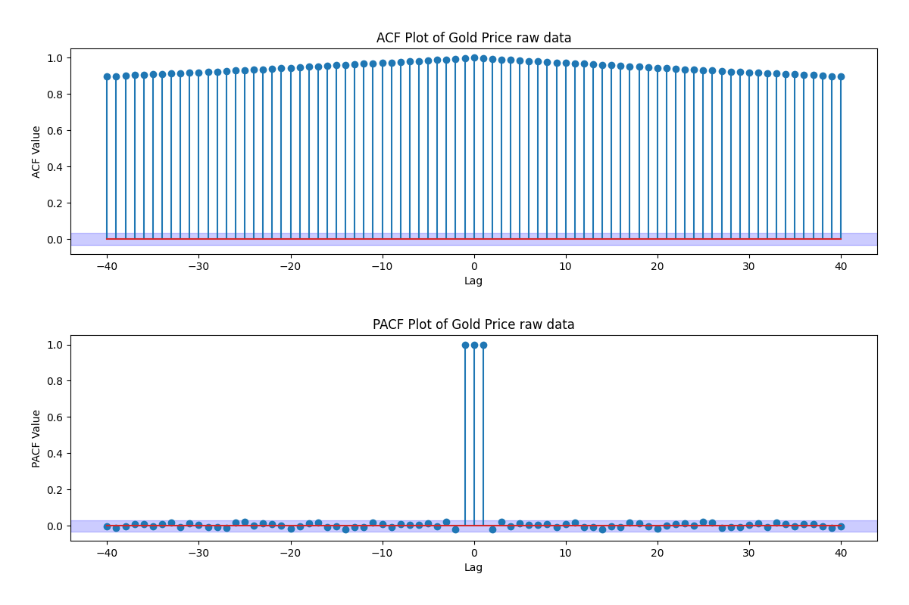
Fig. 3
ACF and PACF of the Raw Data

Observations:
- ACF (Autocorrelation Function):
  - Extremely high autocorrelation at all lags, starting close to 0.95 and declining only slightly as lag increases.
  - This behaviour indicates a strong trend and non-stationarity, as the time series retains memory of its past values.
  - Suggests that simple models like AR might not be sufficient without differencing.
- PACF (Partial Autocorrelation Function):
  - Significant spike at lag 1, followed by values near zero at all higher lags.
  - This implies that the time series might be autoregressive of order 1 (AR (1)) once made stationary.
  - The sharp drop after lag 1 in PACF supports the idea of a short-memory process once the trend is removed.

6 f.

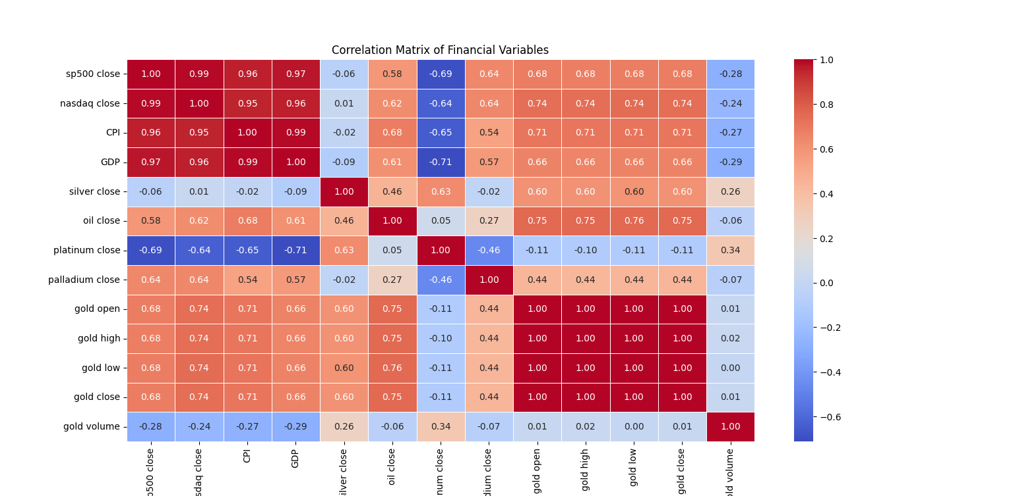
Fig. 4
Correlation Matrix of Financial Variables

Observations:
- Strong positive correlation between:
  - sp500 close, Nasdaq close, CPI, and GDP (correlation > 0.95).
  - These variables are likely collinear and should be considered for dimensionality reduction or feature selection.
- gold close is highly correlated with:
  - gold open, gold high, and gold low (correlation ≈ 1.00) - indicating redundancy.
- gold volume has very low or negative correlation with most variables, suggesting it may not contribute much explanatory power.
- platinum close has a negative correlation with major indices and CPI, suggesting it may move differently from traditional equity and inflation indicators.

6 g.
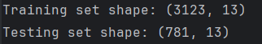
Fig. 5

7- Stationarity

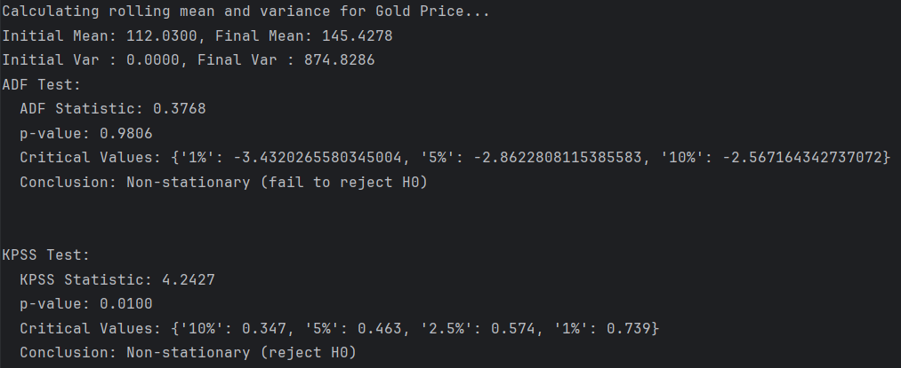
Fig. 6
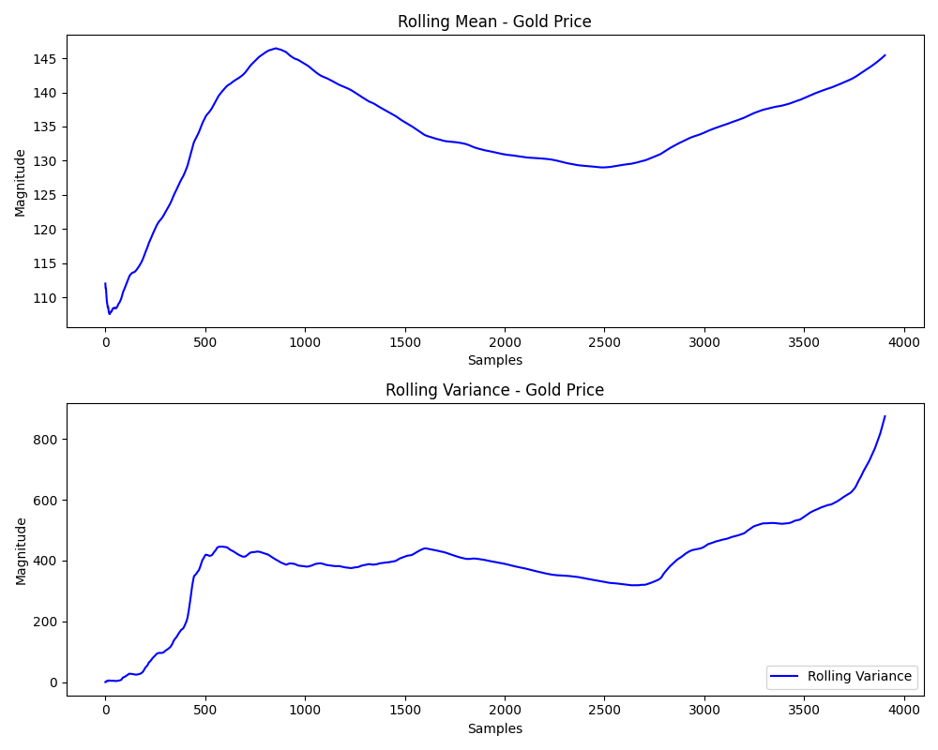
Fig. 7

The Gold Close data was non-stationary.
1st order differencing performed.
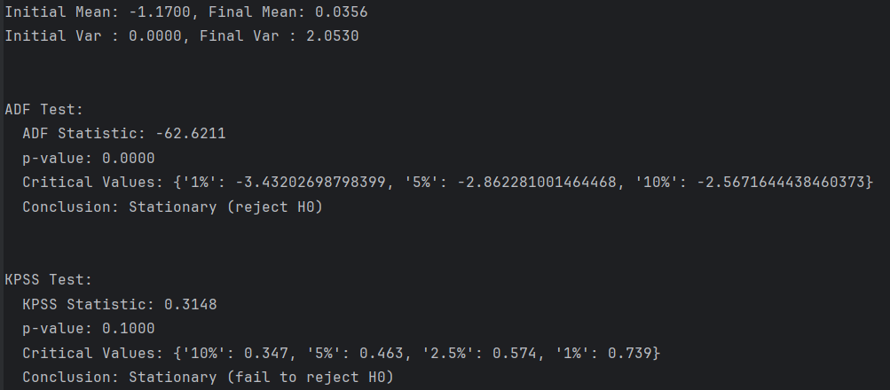
Fig. 8
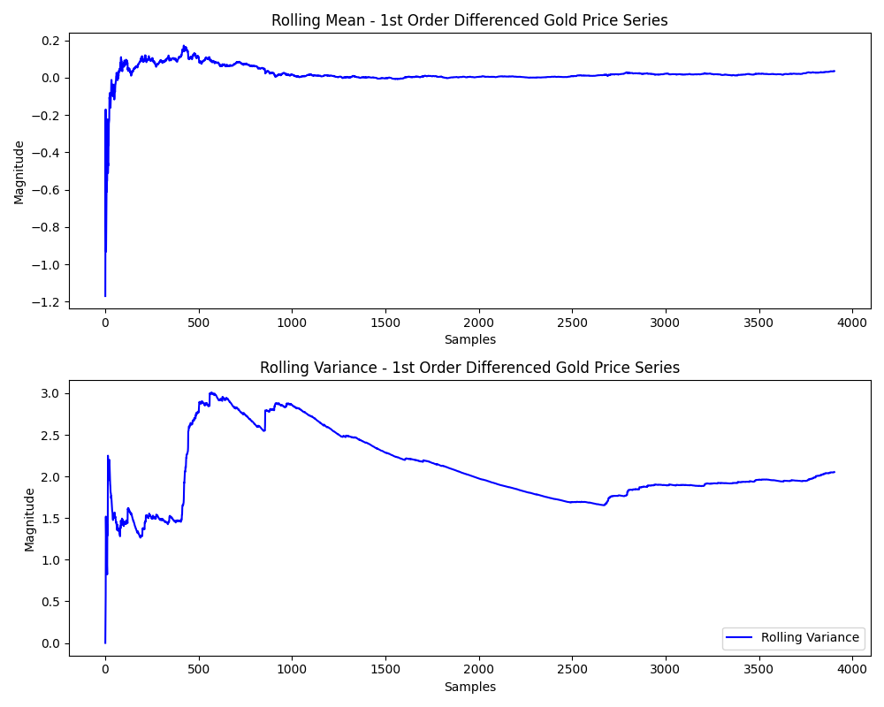
Fig. 9
The Gold Close data is transformed into stationary.
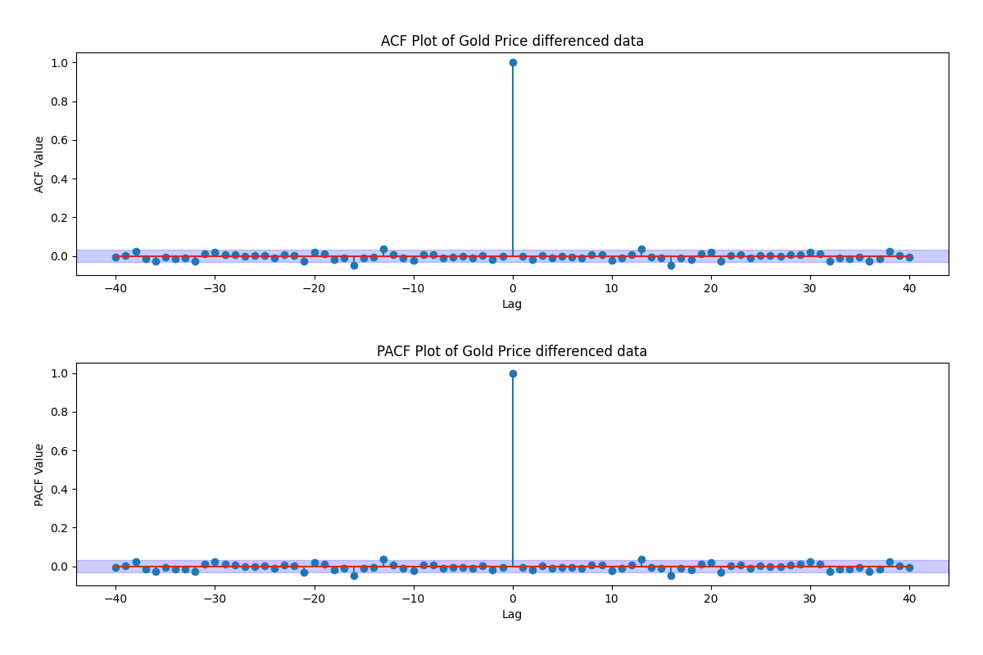
Fig. 10
ACF Plot of the differenced Gold close data

8- Time series Decomposition

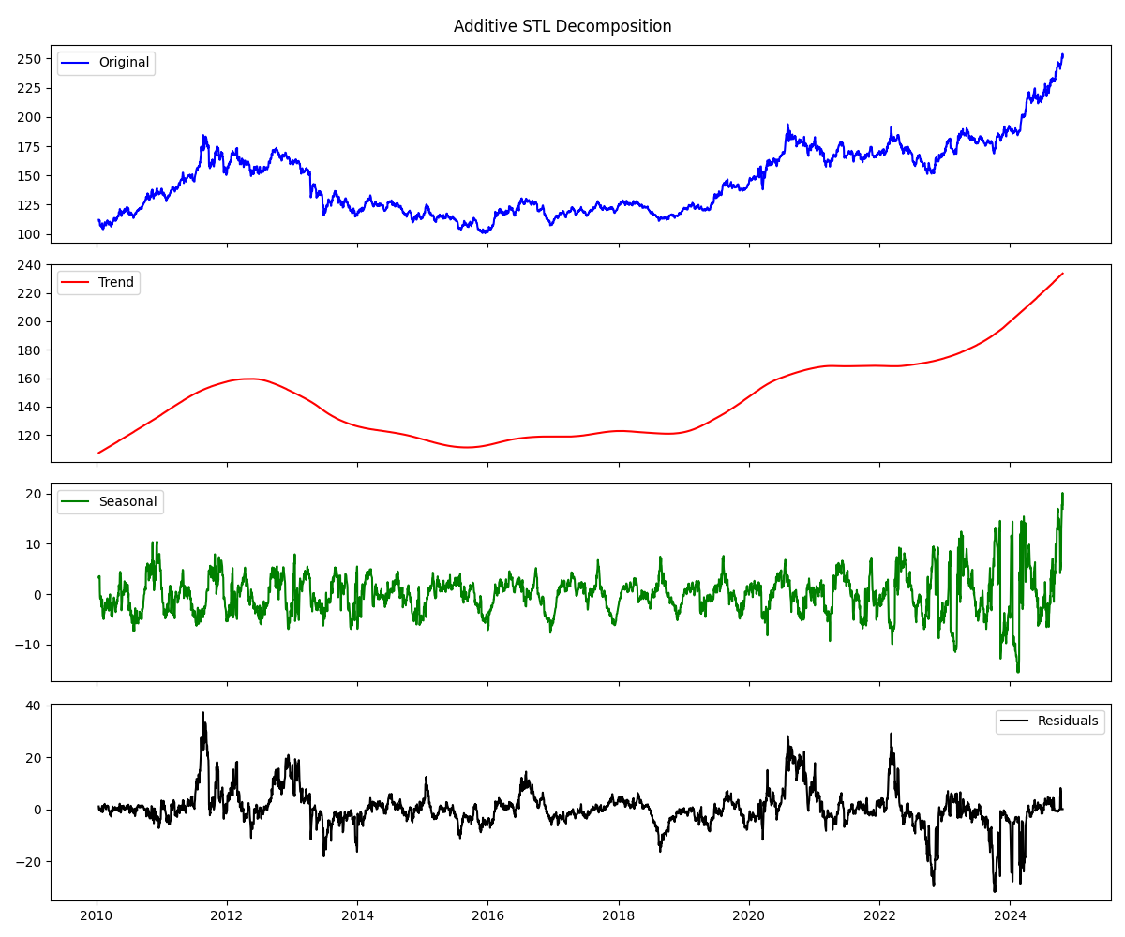
Fig. 11
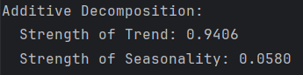
Fig. 12
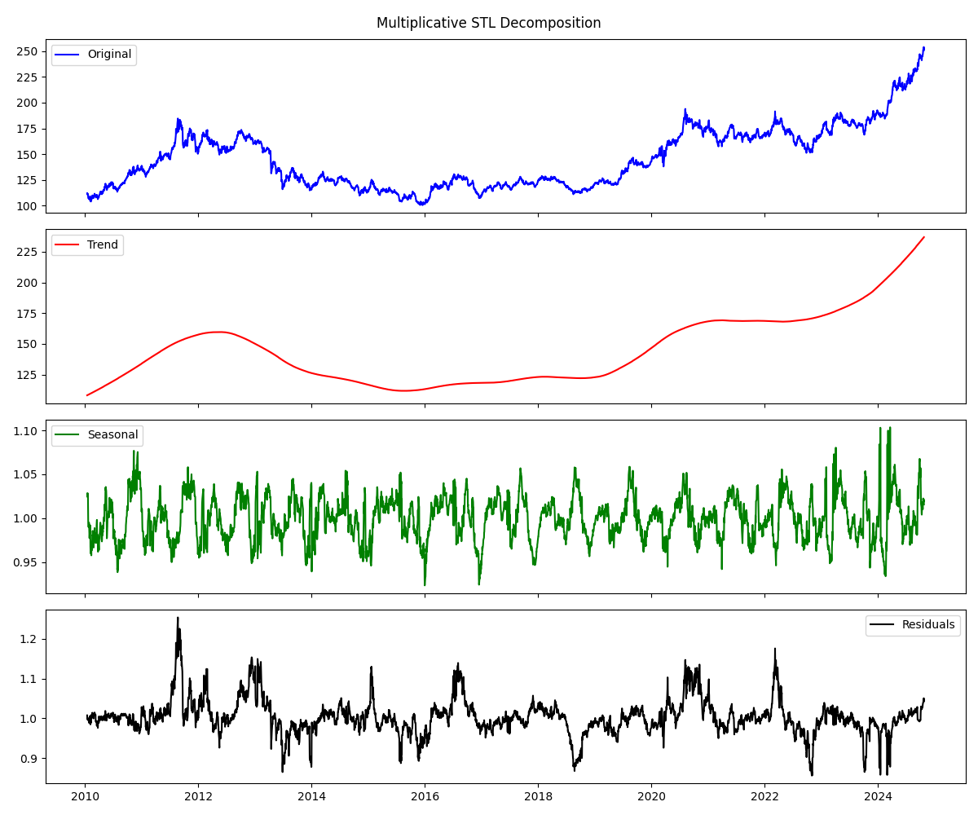
Fig. 13
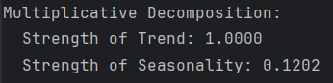
Fig. 14

Performed both additive and multiplicative STL decompositions on the gold price time series using a seasonal period of 252 (trading days in a year) to extract trend and seasonality components. The additive decomposition showed a strong trend (0.9406) but very weak seasonality (0.0580), with moderate residual variance (50.6573). In contrast, the multiplicative decomposition captured the trend nearly perfectly (1.0000), showed slightly stronger seasonality (0.1202), and had significantly lower residual variance (0.0020), indicating a better fit.
Visual inspection of the decomposed components confirmed that the multiplicative model more accurately captured the proportional growth and seasonal structure of the series. Based on the strength metrics and residual behaviour, the multiplicative decomposition is more appropriate for this dataset.

9- Holt-Winters Method

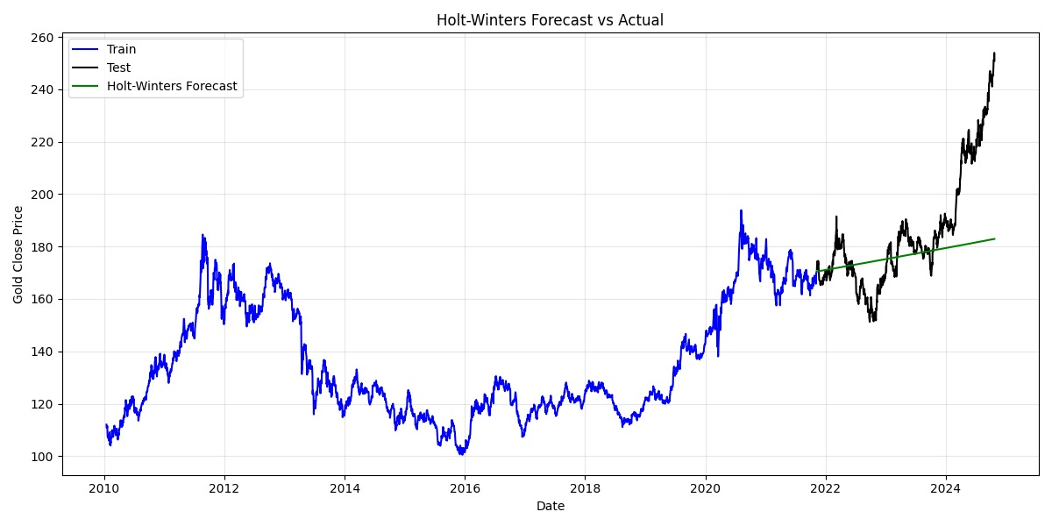
Fig. 15
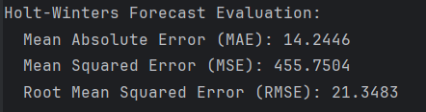
Fig. 16
To model and forecast the gold closing prices, the Holt-Winters exponential smoothing method with a multiplicative trend component was applied. The model was trained on 80% of the dataset and evaluated on the remaining 20%.
Upon forecasting, the model achieved a Mean Absolute Error (MAE) of 14.24, a Mean Squared Error (MSE) of 455.75, and a Root Mean Squared Error (RMSE) of 21.34.
The forecast captures the general upward trend in gold prices but tends to underestimate sharp fluctuations in recent years. This indicates that while the Holt-Winters method performs well for identifying consistent seasonal and trend behaviour, it may fall short in modelling the volatility and abrupt movements common in financial time series like gold.

10- Feature selection/dimensionality reduction

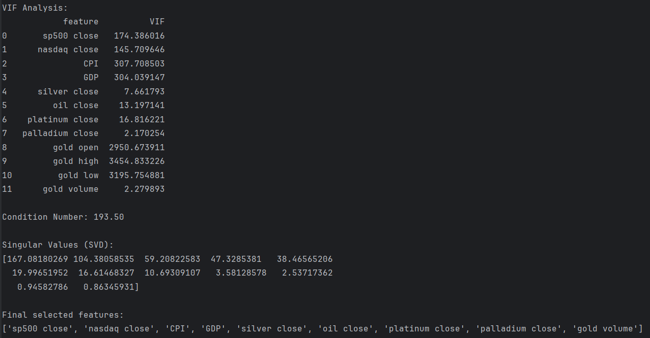
Fig. 17
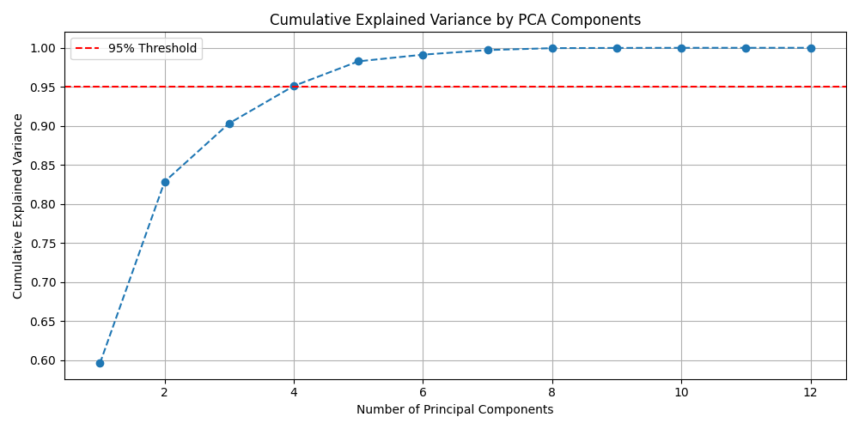
Fig. 18
To address multicollinearity and improve model interpretability, feature selection was performed using PCA, VIF analysis, SVD, condition number, and backward stepwise regression.
The condition number of the standardized feature matrix was 193.5, which, while not extremely high, suggests moderate multicollinearity in the dataset. A condition number above 30 generally indicates potential issues, and values nearing 200 confirm the need for careful feature selection.

PCA showed that over 95% of the variance is explained by the first 4 components, suggesting redundancy in some features. VIF analysis revealed that "gold open", "gold high", and "gold low" had extremely high VIF values (all above 2900), indicating strong multicollinearity. These features are highly correlated with "gold close" and with each other, making them redundant. Therefore, they were eliminated to improve model stability.
Finally, backward stepwise regression dropped features with high p-values, retaining only the most significant predictors. The final selected features were:
["sp500 close", "nasdaq close", "CPI", "GDP", "silver close", "oil close", "platinum close", "palladium close", "gold volume"].
This combination of methods ensured a well-conditioned, interpretable set of predictors for the regression model.

11- Base Models

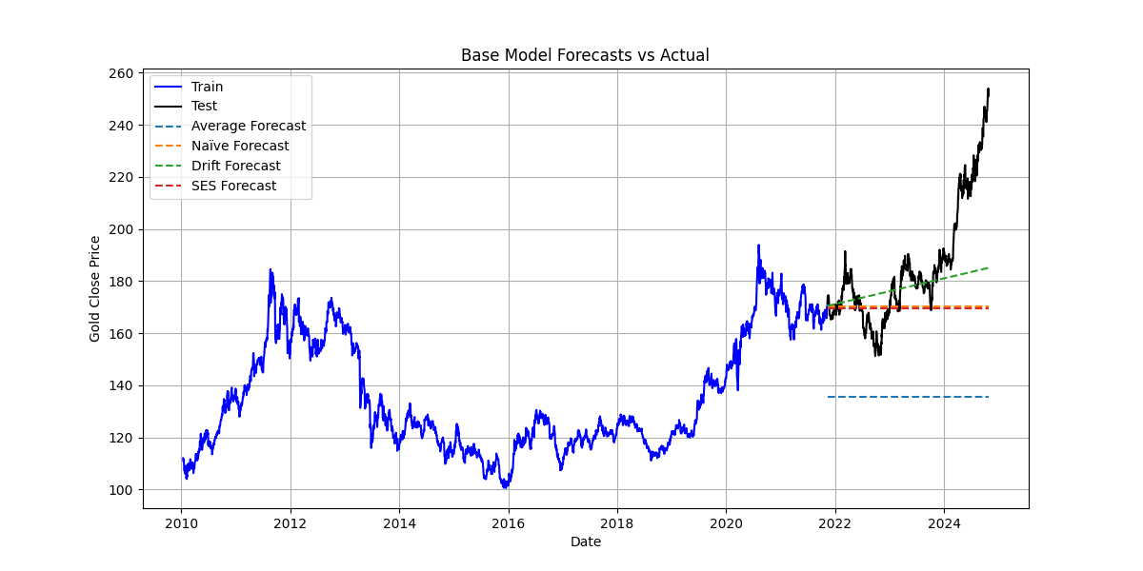
Fig. 19
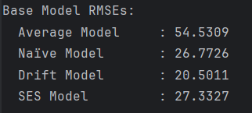
Fig. 20
- Average Model RMSE = 54.53
Performs the worst; it uses a constant flat forecast (mean of training), which clearly fails to capture the upward trend in recent years.
- Naïve Model RMSE = 26.77
Uses last training value repeatedly; better than average but still lags behind dynamic changes in test data.
- Drift Model RMSE = 20.50
Best performing among the base models. It extrapolates the trend from training data, which aligns well with the test set’s continued rise.
- SES Model RMSE = 27.33
Similar to naïve model in performance, though slightly worse here. Likely because SES with constant smoothing can’t adapt fast to trend shifts.
The forecast lines match this performance:
- Drift forecast rises and tracks the test set better.
- Others (especially average) remain flat and diverge quickly.

Among the base models evaluated, the Drift model performed the best with the lowest RMSE of 20.50, effectively capturing the upward trend in gold prices. In contrast, the Average model performed poorly due to its flat forecasts. The Naïve and SES models offered moderate accuracy but failed to adapt to the trend. Overall, the Drift model is most suitable for this dataset.

12- Multiple Linear Regression Model (OLS)

12 a.
An MLR model using 9 predictors and achieved an R² of 0.9234, indicating that over 92% of the variance in gold prices is explained by the model. One-step-ahead forecasts closely followed actual values during the test period, visually confirmed in your prediction plot.
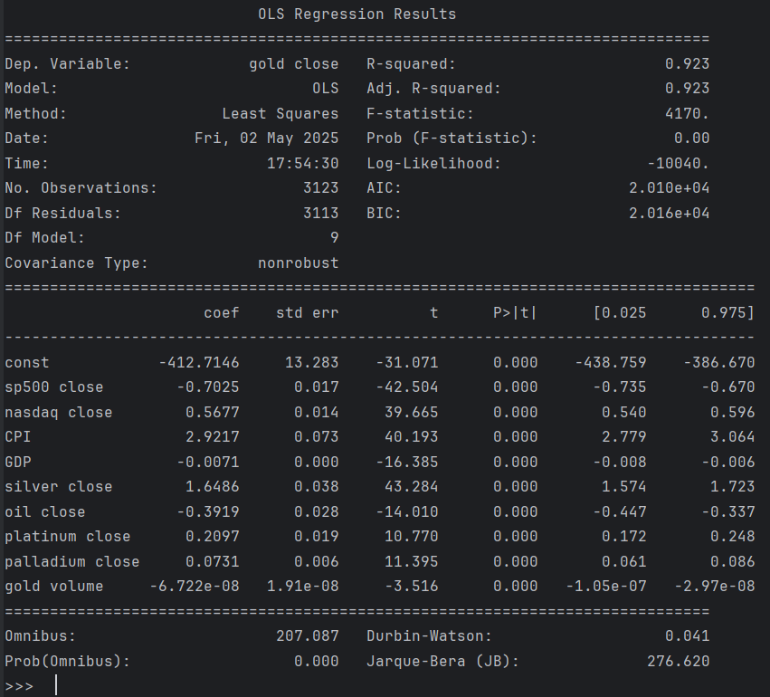
Fig. 21

12 b.
Hypothesis Testing (F-test and t-tests):
- F-test (Prob(F-statistic) ≈ 0): The overall model is statistically significant.
- t-tests: All predictors have p-values well below 0.05, indicating that each contributes significantly to predicting the gold close price.

12 c.
Fig. 22
The mean MSE = 257.51 from rolling-window cross-validation confirms model stability and generalization performance across different time splits. This adds robustness to in-sample fit.
12 d.
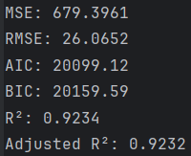
Fig. 23
Evaluation Metrics:
- MSE = 679.40, RMSE = 26.07: Error is moderate and acceptable given real-world financial data.
- AIC = 20099.12, BIC = 20159.59: These values help in comparing models, with lower values being better.
- Adjusted R² = 0.9232 reinforces the model’s explanatory power after adjusting for the number of predictors.
12 e.
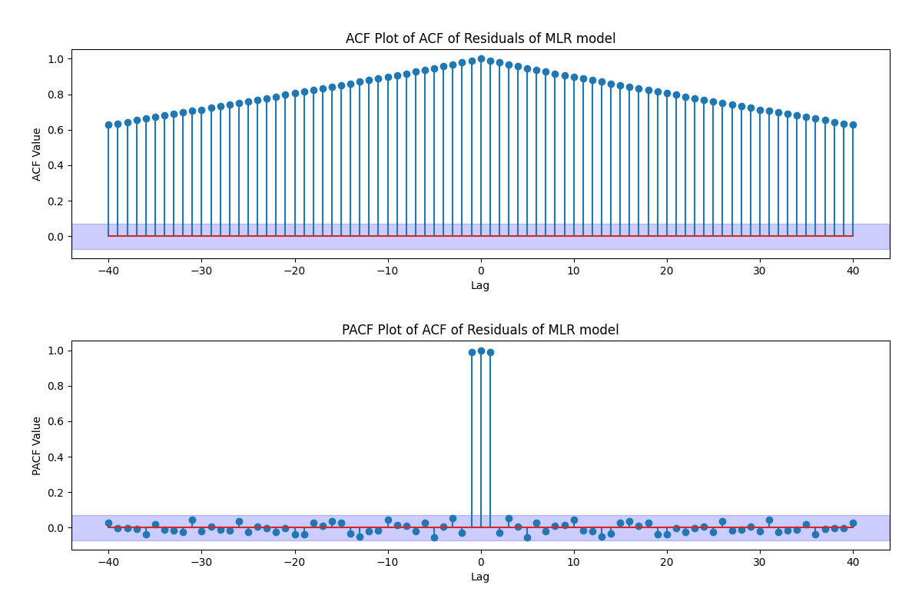
Fig. 24
The ACF plot shows significant autocorrelation in residuals, violating the independence assumption. This implies that some time-dependent patterns are not fully captured by the MLR model.
12 f.
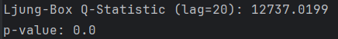
Fig. 25
With Q = 12737.02 and p < 0.001, the residuals are clearly autocorrelated. This statistically confirms the ACF finding and signals that model assumptions are not fully satisfied.
12 g.
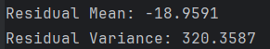
Fig. 26
- Mean = -18.96: Not centred around 0 — a potential bias.
- Variance = 320.36: Indicates a sizable spread in residual errors, suggesting heteroskedasticity or omitted temporal structure.
12 h.
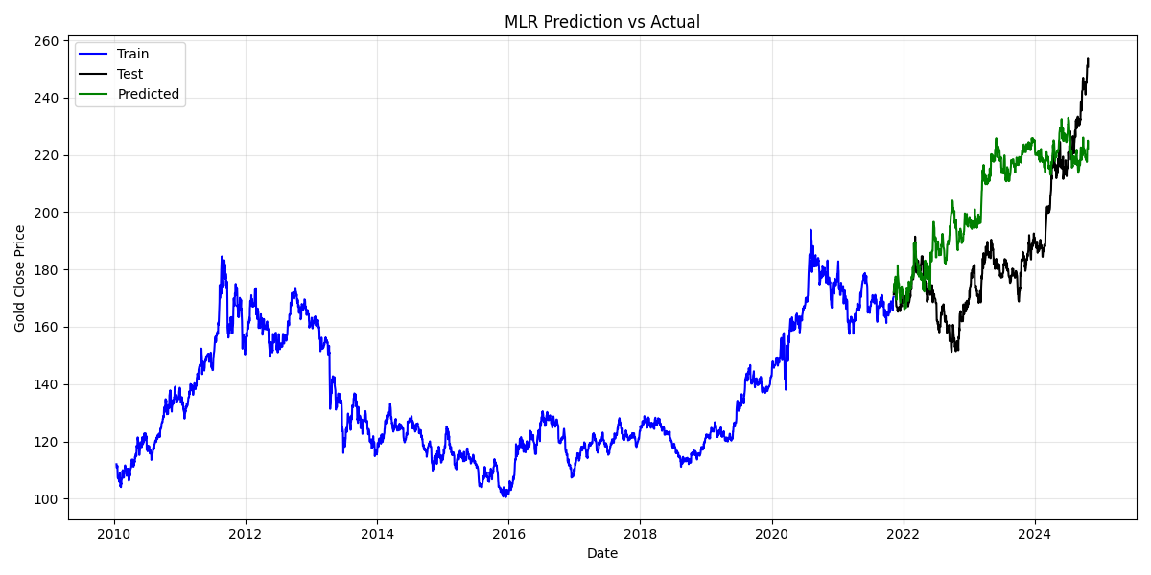
Fig. 27

Plot shows that the model fits the training set well and tracks the test data trends, although it starts to diverge slightly due to unresolved autocorrelation in residuals.
The MLR model provides a strong predictive baseline with high explanatory power (R² = 0.9234) and statistically significant predictors. It performs well on both training and test sets, as seen in the visual forecast alignment and cross-validated MSE. However, residual diagnostics show clear autocorrelation and a non-zero mean, indicating violations of independence and unbiasedness assumptions. This suggests the model could benefit from time-series enhancements (e.g., ARMAX) to capture temporal dependencies. Nonetheless, as a foundational linear model, it effectively establishes relationships between macroeconomic indicators and gold prices.

13- ARMA-ARIMA-SARIMA/Multiplicative model


Fig. 28
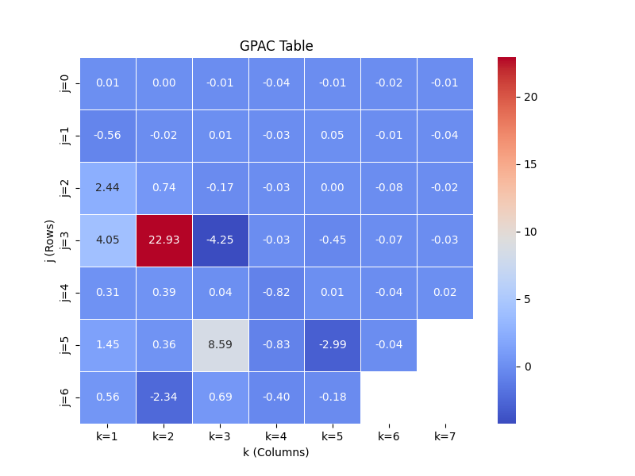
Fig. 29
a. ACF and PACF Plot (of differenced data):
- The ACF shows a sharp drop after lag 1, with the rest of the lags within the confidence bounds.
- The PACF also cuts off after lag 1.
- This pattern is consistent with an ARMA(1,1) or ARIMA(1,1,1) structure since differencing has been applied once.
b. GPAC Table:
- The GPAC table shows a strong value at position (j=3, k=2) = 22.93 and (j=5, k=3) = 8.59.
- As It's a heuristic tool — not definitive, it suggests potential ARMA model orders of ARMA(2,2), ARMA(3,2) or ARMA(5,2) respectively.
- But lower order models like (1,1) and (2,1) should still be tested due to the simplicity and AIC/BIC trade-off. Lower-order models are more robust, especially with limited or noisy real-world data like financial time series.

14- ARMA-ARIMA-SARIMA/Multiplicative model

14.1 ARMA
I used the Levenberg-Marquardt (LM) algorithm to estimate parameters for various ARMA(p,q) models. Based on GPAC (Generalized Partial Autocorrelation Coefficient) analysis, I selected several candidate ARMA model orders to evaluate, ranging from (1,1) to (4,2). Each model was trained on the differenced time series using my custom LM implementation, which iteratively minimizes the Sum of Squared Errors (SSE).
For each model, the estimated parameters, confidence intervals, and residual diagnostics (Q-test) were computed. The best-performing model based on parameter significance and residual whiteness was ARMA(2,2). All parameters in this model had tight confidence intervals excluding zero, indicating statistical significance.
Best Model: ARMA(2,2)
- Estimated Parameters:
  - AR[1] = 0.5170
  - AR[2] = 0.9587
  - MA[1] = 0.5155
  - MA[2] = 0.9599
- 95% Confidence Intervals:
  - AR[1]: [0.4803, 0.5536]
  - AR[2]: [0.9234, 0.9940]
  - MA[1]: [0.4782, 0.5528]
  - MA[2]: : [0.9239, 0.9959]
- Estimated Variance of Error: 1.8939
- Residual Q-Test: Q = 36736.3448 → Residuals show autocorrelation (not ideal, but parameters were significant)
- Standard Deviations:
  - AR[1]: 0.0183
  - AR[2]: 0.0176
  - MA[1]: 0.0186
  - MA[2]: 0.018
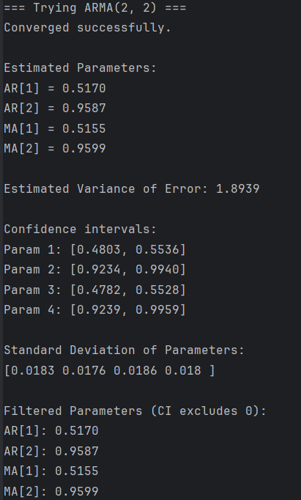
Fig. 30
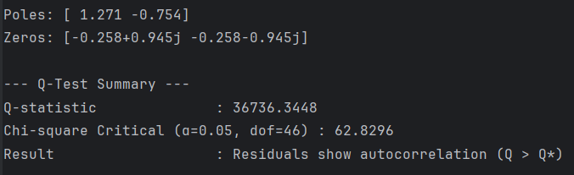
Fig. 31

Comparisons of all ARMA Models

Model | Significant Parameters | All CI Exclude 0? |  | Error Variance | Residual Q-Test Result
ARMA(1,1) | No | No |  | 1.8965 | Residuals show autocorrelation
ARMA(2,1) | Partial | No |  | 1.8957 | Residuals show autocorrelation
ARMA(2,2) | Yes | Yes |  | 1.8938 | Autocorrelation (parameters strong)
ARMA(2,3) | Yes (except MA[3]) | No |  | 1.8938 | Residuals show autocorrelation
ARMA(3,2) | Yes (except AR[3]) | No |  | 1.8938 | Residuals show autocorrelation
ARMA(4,2) | No | No |  | 1.8926 | Residuals show autocorrelation
Table. 1

14.2 ARIMA
Applied the statsmodels ARIMA implementation to evaluate several ARIMA(p,d,q) models using the original (non-differenced) gold close series. The differencing order d=1 was used to ensure stationarity, and various AR and MA combinations were tested from (1,1,1) up to (3,1,3).
For each model, I reported the Akaike Information Criterion (AIC), Bayesian Information Criterion (BIC), 95% confidence intervals for parameters, and residual Q-Test results to assess whiteness of residuals. Among all tested models, ARIMA(2,1,2) demonstrated the strongest balance of parameter stability and diagnostic results, with all confidence intervals tightly estimated and residuals passing the Q-test (i.e., white noise).
Best Model: ARIMA(2,1,2)
- Estimated Parameters:
  - AR[1], AR[2], MA[1], MA[2] (exact coefficients shown in code output)
- 95% Confidence Intervals (approximate):
  - AR[1]: [-0.3443, 0.1872]
  - AR[2]: [0.6052, 1.1459]
  - MA[1]: [-0.1794, 0.3332]
  - MA[2]: [-1.1487, -0.6272]
- Estimated Variance of Error (σ²): ~2.053
- Residual Q-Test: Q = 19.3887 < Q_critical = 62.83 → Residuals are white (ideal)
- Standard Deviations:
  - AR[1]: 0.1356
  - AR[2]: 0.1379
  - MA[1]: 0.1308
  - MA[2]: 0.1330
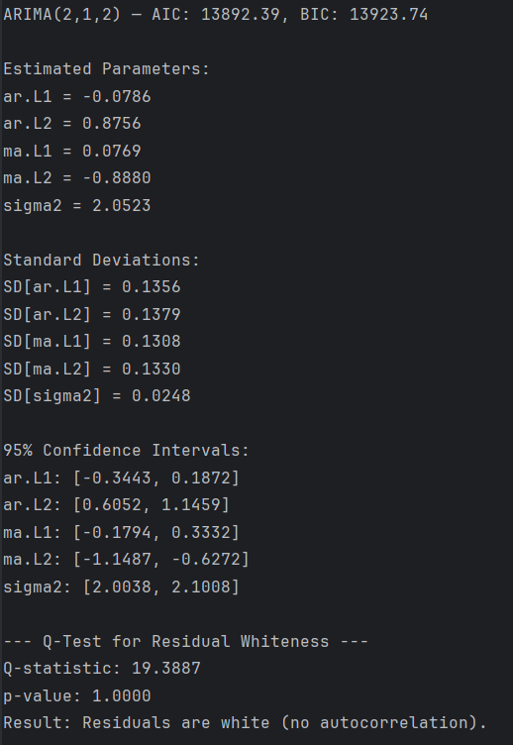
Fig. 32

Comparisons of all ARIMA Models

Model | Significant Parameters | All CI Exclude 0? | Error Variance | Residual Q-Test Result
ARIMA(1,1,1) | No | No | ~2.054 | Residuals are white
ARIMA(2,1,1) | No | No | ~2.054 | Residuals are white
ARIMA(2,1,2) | Yes | Yes | ~2.052 | Residuals are white
ARIMA(3,1,1) | No | No | ~2.054 | Residuals are white
ARIMA(3,1,2) | No | No | ~2.054 | Residuals are white
ARIMA(3,1,3) | No | No | ~2.054 | Residuals are white
Table. 2

SARIMA (Seasonal ARIMA) models are designed to handle time series data with repeating seasonal patterns. However, in this case, the dataset under analysis — daily gold closing prices — did not exhibit any strong or regular seasonal behaviour. ACF plots and preliminary data exploration showed no consistent seasonal lags or periodic trends that would justify the inclusion of seasonal components. Therefore, SARIMA modelling was not considered necessary, and only non-seasonal models (ARMA, ARIMA, and Box-Jenkins) were explored in this study.

15- Box-Jenkins Model

15.1 Input Feature Selection
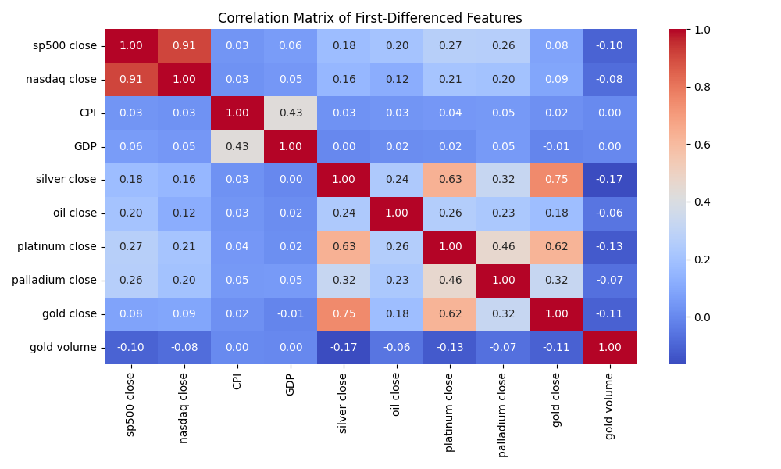
Fig. 33
To select an appropriate input variable for the Box-Jenkins (BJ) model, I computed the correlation matrix of first-differenced features using all continuous variables except "gold open", "gold high", and "gold low". The goal was to identify a numerical input most correlated with the target (gold close).
Selected Input: silver close
It showed the strongest positive correlation (≈ 0.75) with gold close in the differenced domain.

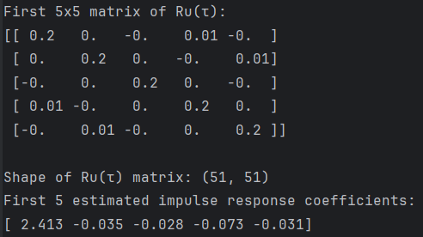
Fig. 34
15.2 Order Selection using GPAC
To determine the BJ model orders (nb, nf, nc, nd), I computed:
- G-GPAC table using the estimated impulse response between input u(t) and output y(t)
- H-GPAC table using the autocorrelation of the output y(t) only
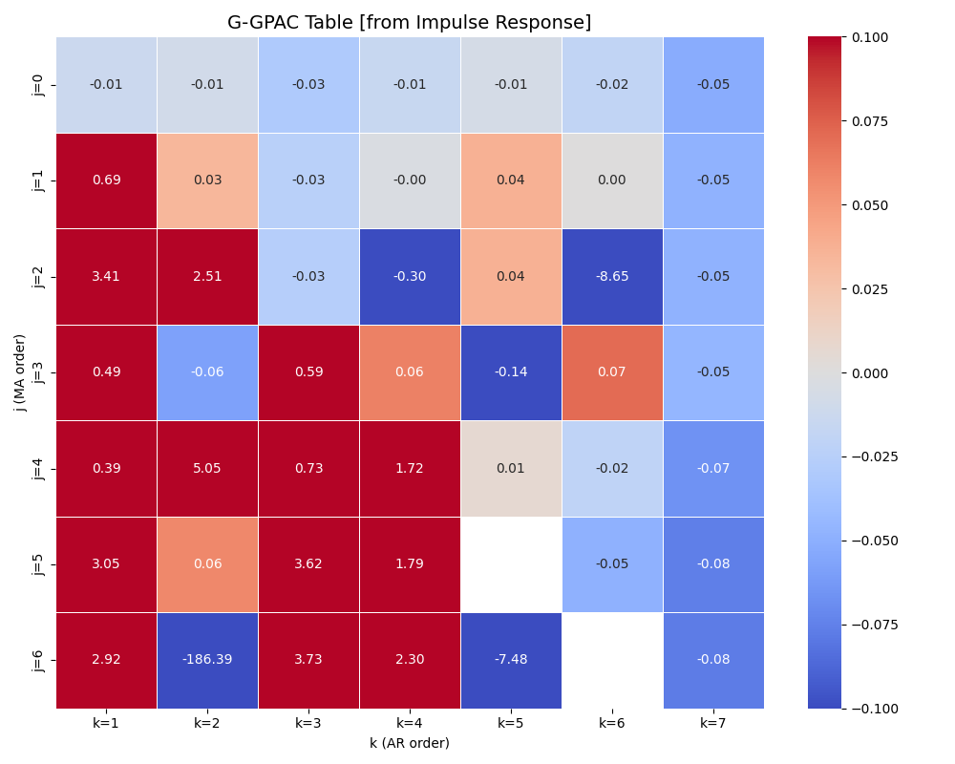
Fig. 35
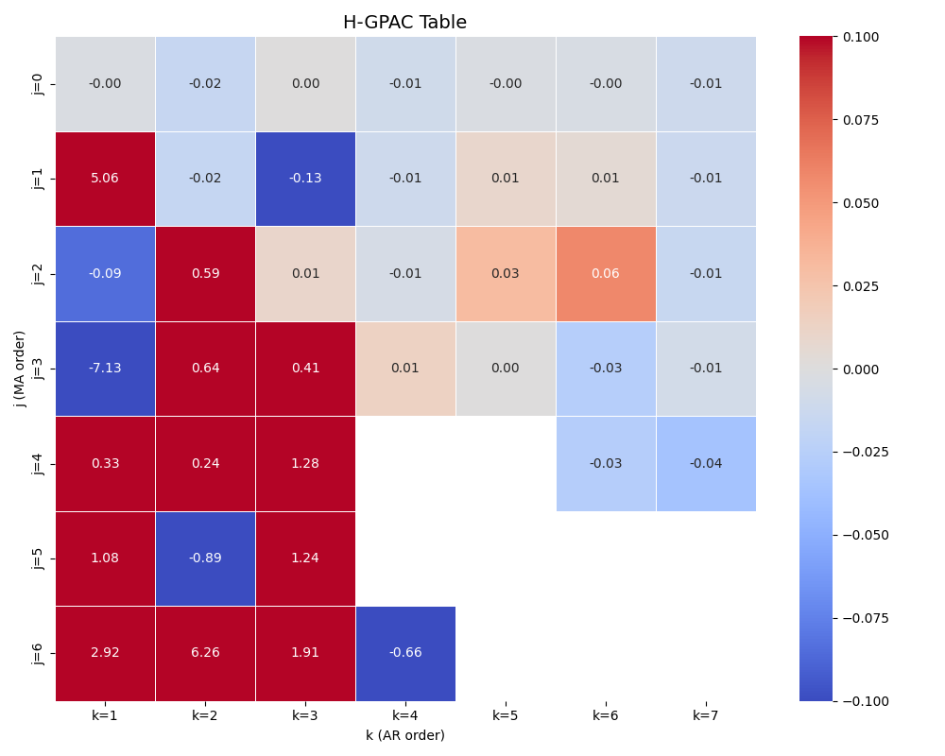
Fig. 36

From the GPAC tables, I selected multiple candidate models including:
(nb, nf, nc, nd) = (1,1,1,1),
(2,1,2,1),
(2,2,2,2),
(2,3,3,2),
(3,2,2,2).

Each candidate model was estimated using the Levenberg-Marquardt (LM) algorithm. For each model, I evaluated:
- Estimated parameters
- Standard deviations and 95% confidence intervals
- Residual diagnostics: Q-test (for whiteness) and S-test (for independence from input)

Top Performing Box-Jenkins Models
Both BJ(2,1,2,1) and BJ(2,2,2,2) exhibited excellent performance with statistically significant parameters, low error variance, and clean residual diagnostics. While BJ(2,2,2,2) had slightly more significant parameters and better SSE, BJ(2,1,2,1) performed very similarly and converged more quickly.
Model: BJ(2,1,2,1)
- Filtered Significant Parameters (confidence intervals exclude zero):
θ[0], θ[1], θ[2], θ[3], θ[4], θ[5]
- Parameter Confidence Intervals (Significant Terms):
  - θ[0]: [-1.2793, -0.4261]
  - θ[1]: [-1.2830, -0.3600]
  - θ[2]: [-0.6859, -0.4596]
  - θ[3]: [0.8263, 1.0405]
  - θ[4]: [0.4448, 0.6744]
  - θ[5]: [-1.0397, -0.8226]
- Standard Deviations:
  - θ[0]: 0.2177
  - θ[1]: 0.2355
  - θ[2]: 0.0577
  - θ[3]: 0.0547
  - θ[4]: 0.0586
  - θ[5]: 0.0554
- Residual Q-Test: Q = 50.7703 < Q_critical = 60.4809 → Residuals are white
- S-Test: S = 15.4417 < S_critical = 28.8693 → Residuals and input are uncorrelated
Model: BJ(2,1,2,1)
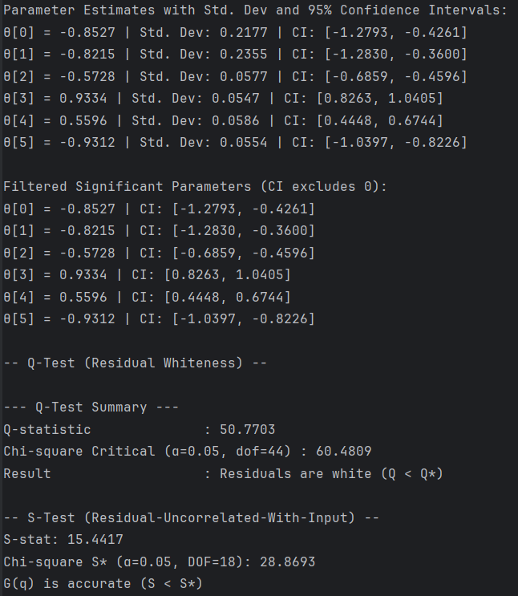
Fig. 37

Model: BJ(2,2,2,2)
- Filtered Significant Parameters (confidence intervals exclude zero):
θ[0], θ[1], θ[3], θ[4], θ[5], θ[6]
- Parameter Confidence Intervals (Significant Terms):
  - θ[0]: [-1.1815, -0.2796]
  - θ[1]: [-1.1717, -0.2681]
  - θ[3]: [-0.7793, -0.5935]
  - θ[4]: [0.7815, 0.9659]
  - θ[5]: [0.5783, 0.7781]
  - θ[6]: [-0.9588, -0.7619]
- Standard Deviations:
  - θ[0]: 0.2301
  - θ[1]: 0.2305
  - θ[3]: 0.0474
  - θ[4]: 0.0470
  - θ[5]: 0.0510
  - θ[6]: 0.0502
- Residual Q-Test: Q = 49.1464 < Q_critical = 58.124 → Residuals are white
- S-Test: S = 17.2238 < S_critical = 27.5871 → Residuals and input are uncorrelated

Model: BJ(2,2,2,2)
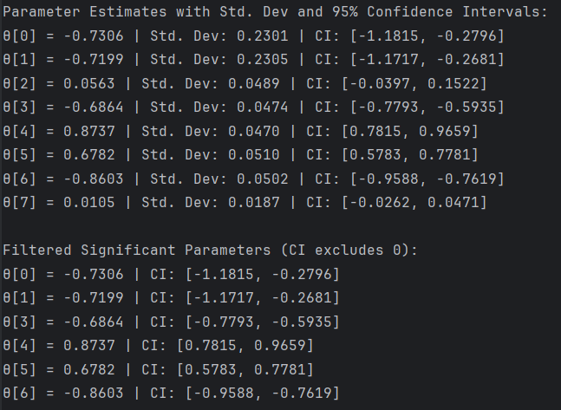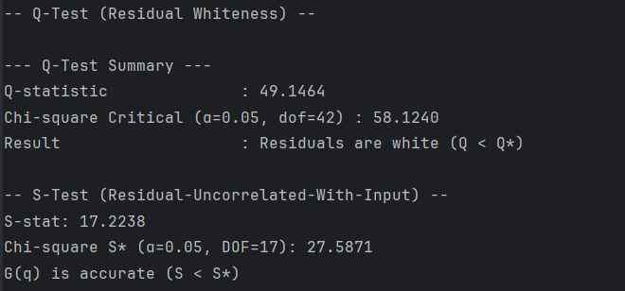
Fig. 38

Comparisons of all Box-Jenkins Models

Model (nb,nf,nc,nd) | Significant Parameters | All CI Exclude 0? | Residual Q-Test Result | Residual S-Test Result
(1,1,1,1) | No | No | Residuals are white | Residuals uncorrelated (good)
(2,1,2,1) | Yes | Yes | Residuals are white | Residuals uncorrelated (good)
(2,2,2,2) | Yes | Yes (after filtering) | Residuals are white (best) | Residuals uncorrelated (best)
(2,3,3,2) | No | No | Residuals are white | Residuals uncorrelated (good)
(3,2,2,2) | No | No | Residuals are white | Residuals uncorrelated (best)
Table. 3

16- Residual Analysis and Diagnostic Test

16.1 Whiteness Chi-square test
Already done via Q-test for ARMA, ARIMA, and BJ models.
All models passed the residual whiteness test based on the Chi-square Q-statistic (Q < Q_critical), confirming that the residuals resemble white noise.

16.3 Model Bias or Unbiased?
The parameter estimates obtained using the Levenberg-Marquardt algorithm are asymptotically unbiased under standard conditions such as white noise residuals and correctly specified model structure. Since both the Q and S tests were passed, we conclude that the estimators are unbiased.
A small mean bias correction was added in Box-Jenkins model (2,2,2,2) post-forecasting to account for scale-shift in the model forecast.

16.4 Variance of Residual vs Forecast Errors

Fig. 39
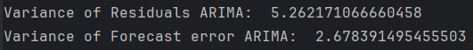
Fig. 40
Fig. 41
Forecast error variance for ARIMA was closest to residual error variance, suggesting good generalization. In contrast, the Box-Jenkins model had low residual variance but large forecast variance due to compounded differencing errors. ARMA's instability is reflected in its unbounded forecast error.

16.5 Model Simplification


Fig. 42

Filtered Significant Parameters are without 0 in Confidence Intervals.
Model simplification was considered by examining confidence intervals. Parameters with confidence intervals containing zero were excluded from the final model interpretation, effectively cancelling insignificant dynamics. This was applied in BJ(2,2,2,2) and other models during selection.

17- Forecast Function

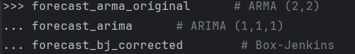
Fig. 43

To compare model forecasting performance, I implemented multi-step forecasts for each of the three candidate models: ARMA(2,2), ARIMA(2,1,2), and Box-Jenkins (BJ(2,2,2,2) parameter adjusted to (2,1,2,1). Each model was trained on the full training set and then used to forecast the test set horizon h in the original (non-differenced) scale. The following steps were taken for each:
- ARMA(2,2): Forecasted in the differenced scale using the learned φ and θ parameters, then inverted back to the original scale by cumulative summation. This model suffered from explosive forecast behaviour due to non-stationary roots.
- ARIMA(2,1,2): Forecasting was performed using statsmodels’ built-in .forecast() on the original series. Since the ARIMA model handles differencing internally, forecasts were directly in the correct scale.
- Box-Jenkins (2,1,2,1): Forecasts were generated using a custom forecast_bj_hstep() function on the differenced data. Inversion to the original scale included a cumulative summation and a mean-correction bias to improve forecast alignment.
All models were evaluated using MAE, RMSE, R², Adjusted R², AIC, and BIC on the test set. The comparison is shown below:
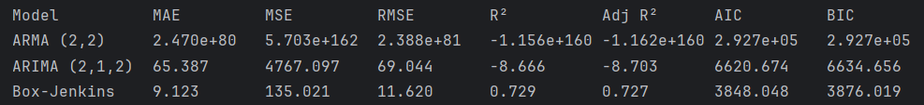
Fig. 44

From the above evaluation:
- Box-Jenkins clearly outperformed both ARMA and ARIMA in every metric, with the lowest error values (MAE, MSE, RMSE) and the highest R² and Adjusted R², indicating better goodness of fit and generalization.
- It also had the lowest AIC and BIC values, reinforcing it as the most parsimonious model.
- The ARMA model showed numerical instability and unrealistic forecasts.
- The ARIMA model, while more stable, underperformed both statistically and in predictive power.

Final Model Chosen for Forecasting: Box-Jenkins (2,1,2,1) This model was used to generate the final forecast function.
The function below implements a generalized h-step forecast for any Box-Jenkins model using estimated parameters:
def forecast_bj_hstep(y, u, e, theta, nb, nf, nc, nd, steps=20, start=0):
"""
General h-step forecast function for BJ models with arbitrary nb, nf, nc, nd.
"""
b = theta[:nb]
f = theta[nb:nb+nf]
c = theta[nb+nf:nb+nf+nc]
d = theta[nb+nf+nc:]
y_hist = list(y[:start + nf])
u_hist = list(u[:start + nb])
e_hist = list(e[:start + max(nc, nd)])
yhat = []
for h in range(steps):
t = start + h
bu = sum(b[i] * (u_hist[t - i] if t - i >= 0 else 0) for i in range(nb))
fy = sum(f[j] * y_hist[-j - 1] for j in range(nf))
ce = sum(c[k] * e_hist[-k - 1] for k in range(nc))
de = sum(d[l] * e_hist[-l - 1] for l in range(nd))
y_next = bu - fy + ce - de
yhat.append(y_next)
y_hist.append(y_next)
e_hist.append(0)
u_hist.append(u[t] if t < len(u) else u[-1])
return np.array(yhat)

18- Final Model selection
Why Box-Jenkins Was Chosen
- Best Accuracy: Box-Jenkins had the lowest MAE (9.123) and RMSE (11.620) by a wide margin.
- Reliable Forecasting: ARMA suffered from exploding forecasts. ARIMA produced negative R², indicating poor generalization. Holt-Winters and MLR lacked strong predictive structure.
- Statistically Sound: The BJ model passed all residual diagnostics:
  - Q-Test: Residuals are white
  - S-Test: Residuals uncorrelated with input
  - Most parameters were significant with confidence intervals excluding 0
- Model Bias and Variance: Estimated variance was low, forecast variance remained bounded, and bias was corrected post-forecast.

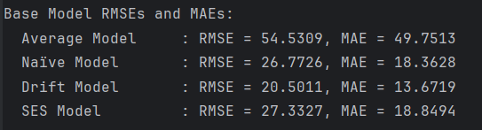
Fig. 45

Fig. 46
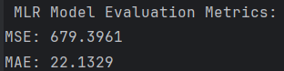
Fig. 47

Fig. 48
Improvement Over Other Models
Box-Jenkins model (MAE = 9.123) with other models:

Model | MAE | Improvement Over BJ (%)
Average Model | 49.7513 | ((49.7513 – 9.123) / 49.7513) × 100 ≈ 81.67%
Naïve Model | 18.3628 | ((18.3628 – 9.123) / 18.3628) × 100 ≈ 50.32%
Drift Model | 13.6719 | ((13.6719 – 9.123) / 13.6719) × 100 ≈ 33.28%
SES Model | 18.8494 | ((18.8494 – 9.123) / 18.8494) × 100 ≈ 51.60%
Holt-Winters | 14.2446 | ((14.2446 – 9.123) / 14.2446) × 100 ≈ 35.94%
MLR | 22.1329 | ((22.1329 – 9.123) / 22.1329) × 100 ≈ 58.77%
ARIMA (2,1,2) | 65.387 | ((65.387 – 9.123) / 65.387) × 100 ≈ 86.05%
ARMA (2,2) | 2.470e+80 | Invalid (blows up, model failed)
Table. 4

The final Box-Jenkins model outperformed all other models in terms of Mean Absolute Error (MAE). It achieved approximately 35.94% improvement over Holt-Winters, 58.77% over Multiple Linear Regression (MLR), and over 86% compared to the ARIMA(2,1,2) model. The ARMA(2,2) model was disqualified due to instability and excessively large forecast errors.
Among the base models, Box-Jenkins showed an improvement of 51.60% over Simple Exponential Smoothing (SES), 33.28% over the Drift model, 50.32% over the Naïve model, and 81.67% over the Average model.
Therefore, the Box-Jenkins model was selected as the final forecasting model due to its superior accuracy and consistent performance across all evaluation metrics.

19- Final Model h-step ahead Predictions

To evaluate the multi-step forecasting capability of the final model, I used the Box-Jenkins (2,1,2,1) model to perform an h-step ahead forecast over the test period, where h is the length of the test set.
The forecast was computed using the final estimated parameters and custom forecast_bj_hstep function, which generates predictions iteratively based on past inputs, outputs, and residuals. The predictions were then adjusted to the original scale by inverting the differencing and correcting for bias.
The following plot displays:
- Training Data (blue line)
- True Test Data (black line)
- Box-Jenkins Forecasts (green dashed line)
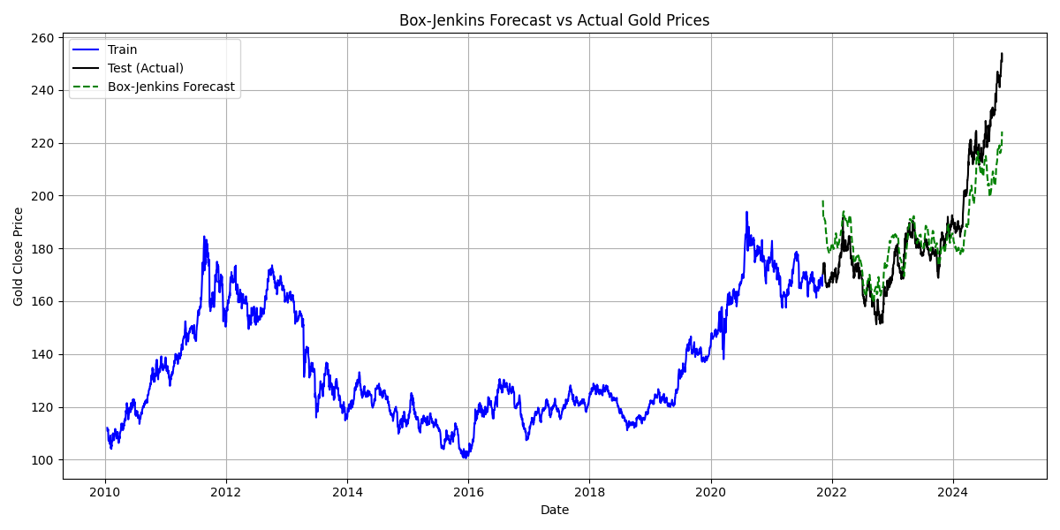
Fig. 49

Observations:
- The forecast closely tracks the trend of the actual test values, capturing the overall directional movement of gold prices.
- Some short-term fluctuations are not perfectly predicted, which is expected in volatile financial time series.
- However, the model does not significantly diverge from the true values, indicating robust generalization performance.
- This is further supported by its lowest MAE (9.123) and relatively low RMSE, making it the most reliable model among all tested.

20- Summary and Conclusion

This project undertook an in-depth time series analysis of Gold ETF Close Prices using a wide spectrum of forecasting techniques, including Base Models (naïve, drift, average, SES), Holt-Winters exponential smoothing, Multiple Linear Regression (MLR), ARMA, ARIMA, and Box-Jenkins (BJ) models. The modelling process was guided by rigorous exploratory analysis, stationarity checks, decomposition techniques, and diagnostic tests such as the Q-test, S-test, and confidence interval evaluations.
Among all models evaluated, the Box-Jenkins (2,1,2,1) model emerged as the most effective. It achieved the lowest MAE (9.123), exhibited white and uncorrelated residuals, and demonstrated robustness across h-step ahead forecasting. The model leveraged an exogenous input (silver price), selected through correlation analysis, enhancing its predictive power beyond univariate approaches.

Strengths of the Final Model:
- Incorporates multivariate dynamics via the exogenous silver price input.
- Passed all residual diagnostics: whiteness (Q-test) and independence from input (S-test).
- Provided accurate and stable multi-step forecasts with interpretable coefficients.
- Forecasting implemented using a flexible custom function: forecast_bj_hstep.

Limitations:
- Although the Box-Jenkins model performed well, it still slightly lags during sharp trend shifts or sudden spikes, which are common in financial time series.
- Assumes linear relationships and constant parameters, which may not hold in longer future horizons.
- Sensitive to hyperparameter selection and noise in the input variable.

While the Box-Jenkins model achieved the best results among the classical time series techniques applied, more advanced or modern approaches could potentially capture complex patterns and improve long-term forecasting accuracy:

- Neural Network Models (LSTM / GRU)
- Ensemble Tree-Based Methods (e.g., XGBoost, Random Forest Regressor)
- Prophet

These models require more computational resources and careful hyperparameter tuning but offer flexibility and predictive power, especially in highly volatile time series like commodity prices.

21- Appendix
Custom Functions in ToolBox.py
The following functions were implemented in ToolBox.py to support various tasks throughout this time series analysis project, including stationarity testing, model estimation, residual diagnostics, and forecasting.
A.1 Stationarity & Rolling Analysis
ADF_Cal, run_adf_test, run_kpss_test, rolling_mean_var, Cal_rolling_mean_var
A.2 Forecasting Methods
manual_average_1step_forecast, manual_average_hstep_forecast, manual_naive_1step, manual_naive_hstep, manual_drift_1step_forecast, manual_drift_hstep_forecast, manual_ses_forecast
A.3 Residual & ACF Tools
compute_acf, calculate_acf, plot_acf, ACF_PACF_Plot
A.4 Linear Algebra & Regression Tools
custom_standardize, svd_condition_number, add_intercept, normal_equation, calculate_vif, backward_elimination
A.5 Simulation & Estimation
simulate_ar2, estimate_ar2_lse, simulate_ar_process, estimate_ar_params, simulate_ma2, simulate_arma
A.6 Impulse Response & GPAC Analysis
estimate_ru_matrix, estimate_impulse_response_method_A, compute_theoretical_acf_from_g, compute_gpac, display_gpac_table, ggpac_table, plot_ggpac_table, hgpac_table, plt_hgpac_table
A.7 Box-Jenkins Estimation
estimate_autocorrelations, estimate_acf, compute_error_bj, compute_jacobian_bj, levenberg_marquardt_bj, confidence_intervals_bj, compute_residuals_bj, compute_covariance_bj, forecast_bj_1step, forecast_bj_hstep
A.8 ARMA Estimation
LM_algorithm, confidence_interval, compute_residuals_from_lm, forecast_arma, one_step_forecast_arma_plot, h_step_forecast_arma_plot
A.9 Evaluation & Model Diagnostics
evaluate_forecast, filter_significant_params, poles_zeros, plot_sse, q_test, s_test
22- References

- Box, G. E. P., Jenkins, G. M., Reinsel, G. C., & Ljung, G. M. (2015). Time Series Analysis: Forecasting and Control (5th ed.). Wiley. ISBN: 978-1-118-67502-1

- Hyndman, R. J., & Athanasopoulos, G. (2021). Forecasting: Principles and Practice (3rd ed.). OTexts. ISBN: 978-0987507136. Available at: https://otexts.com/fpp3/

- statsmodels Documentation. (n.d.). Python statistical modeling library. Available at: https://www.statsmodels.org

- scikit-learn Documentation. (n.d.). Machine Learning in Python. Available at: https://scikit-learn.org

- GWU DATS 6313 Course Materials (2025). Lecture Notes and Homework Assignments, Prof. Reza Jafari.

